**PIZZA SALES SQL QUERY**

1. **KPI’s**
2. Total Revenue:

SELECT SUM(total_price) AS Total_Revenue from pizza_sales;



1. SELECT SUM(total_price)/COUNT(DISTINCT order_id) AS Avg_order_Value from pizza_sales;



1. Total Pizzas sold

SELECT SUM(quantity) as Total_Pizza_Sold FROM pizza_sales;



1. Total Order placed

Select COUNT(DISTINCT order_id) AS Total_order from pizza_sales;



1. Average Pizzas per Order

SELECT CAST(CAST(SUM(quantity) AS DECIMAL(10,2))/CAST(COUNT(DISTINCT order_id) AS DECIMAL(10,2)) AS DECIMAL(10,2)) AS Avg_Pizzas_Per_order FROM pizza_sales



1. **DAILY TRENDS FOR TOTAL ORDERS**

--Daily Trend

SELECT DATENAME(DW, order_date) as order_day, COUNT(DISTINCT order_id) as Total_orders from pizza_sales GROUP BY DATENAME(DW,order_date);

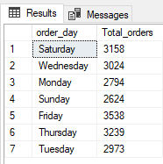

1. **HOURLY TREND FOR ORDERS**

SELECT DATEPART(HOUR,order_time) AS order_hours, COUNT (DISTINCT order_id) AS Total_orders from pizza_sales

GROUP BY DATEPART(HOUR,order_time)

ORDER BY DATEPART(HOUR,order_time);

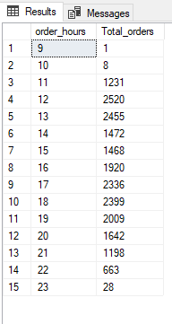

1. **% OF SALES OF PIZZA CATEGORY**

SELECT pizza_category,sum(total_price) as Total_Sales,sum(total_price)*100/(SELECT sum(total_price) from pizza_sales) as PCT

from pizza_sales

GROUP BY pizza_category;

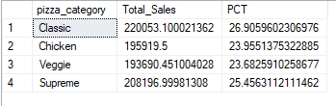

1. **% OF SALES BY PIZZA SIZE**

SELECT pizza_size,sum(total_price) as Total_Sales, CAST(sum(total_price)*100/(SELECT sum(total_price) from pizza_sales) AS DECIMAL(10,2))as PCT from pizza_sales GROUP BY pizza_size;

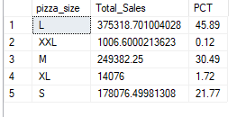

1. **Total Pizzas Sold by Pizza Category**

SELECT pizza_category, sum(quantity) as Total_Pizzas_Sold from pizza_sales Group by pizza_category

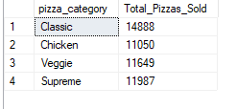

1. **Top 5 Best Sellers by Total Pizzas Sold**

SELECT TOP 5 pizza_name, sum(quantity) as Total_Pizzas_Sold

from pizza_sales Group by pizza_name

ORDER BY sum(quantity) DESC

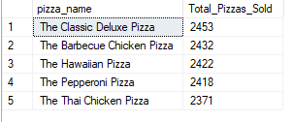

1. **Bottom 5 Best Sellers by Total Pizzas Sold**

SELECT TOP 5 pizza_name, sum(quantity) as Total_Pizzas_Sold

from pizza_sales Group by pizza_name ORDER BY sum(quantity) ASC

